**Cloud computing** is the **delivery of computing services**—including servers, storage, databases, networking, software, analytics, and intelligence—**over the Internet** (“the cloud”) to offer faster innovation, flexible resources, and economies of scale.

# Features

On Demand Services | Measured Services | Pay as you go pricing model | Resource pooling | Rapid Scale/ Elasticity/ Scalability | Broad network access /Global scale/ Geographical Distribution | self-service | Reliability| Disaster Recovery | Secure | High Availability/ Robust/ High Performance | faster innovation

# Cloud deployment or Cloud computing Architecture

# Public Cloud

The cloud resources (like servers and storage) are owned and operated by a third-party cloud service provider and delivered over the internet. With a public cloud, all hardware, software and other supporting infrastructure are owned and managed by the cloud provider.

*Advantages of public clouds:*

* **Lower costs**—no need to purchase hardware or software and you pay only for the service you use.
* **No maintenance**—your service provider provides the maintenance.
* **Near-unlimited scalability**—on-demand resources are available to meet your business needs.
* **High reliability**—a vast network of servers ensures against failure.

# Private Cloud

A private cloud consists of cloud computing resources used exclusively by one business or organization. The private cloud can be physically located at your organization’s on-site datacenter, or it can be hosted by a third-party service provider. But in a private cloud, the services and infrastructure are always maintained on a private network and the hardware and software are dedicated solely to your organization.

*Advantages of a private cloud*:

* **More flexibility**—your organization can customize its cloud environment to meet specific business needs.
* **More control**—resources are not shared with others, so higher levels of control and privacy are possible.
* **More scalability**—private clouds often offer more scalability compared to on-premises infrastructure.

# Hybrid Cloud

A hybrid cloud is a type of [cloud computing](https://azure.microsoft.com/en-in/overview/what-is-cloud-computing/) that combines on-premises infrastructure—or a private cloud—with a public cloud. Hybrid clouds allow data and apps to move between the two environments.

*Advantages of the hybrid cloud:*

* **Control**—your organization can maintain a private infrastructure for sensitive assets or workloads that require low latency.
* **Flexibility**—you can take advantage of additional resources in the public cloud when you need them.
* **Cost-effectiveness**—with the ability to scale to the public cloud, you pay for extra computing power only when needed.
* **Ease**—transitioning to the cloud does not have to be overwhelming because you can migrate gradually—phasing in workloads over time.

# Community Cloud

Community cloud allows systems and services to be accessible by a group of several organizations to share the information between the organization and a specific community. It is owned, managed, and operated by one or more organizations in the community, a third party, or a combination of them.

**Example:** Health Care community cloud

*Advantages of Community Cloud*

* Community cloud is **cost-effective** because the whole cloud is being shared by several organizations or communities.
* It provides **better security** than the public cloud.
* It provides **collaborative** and **distributive environment**.
* Community cloud allows us to **share** cloud resources, infrastructure, and other capabilities among various organizations.

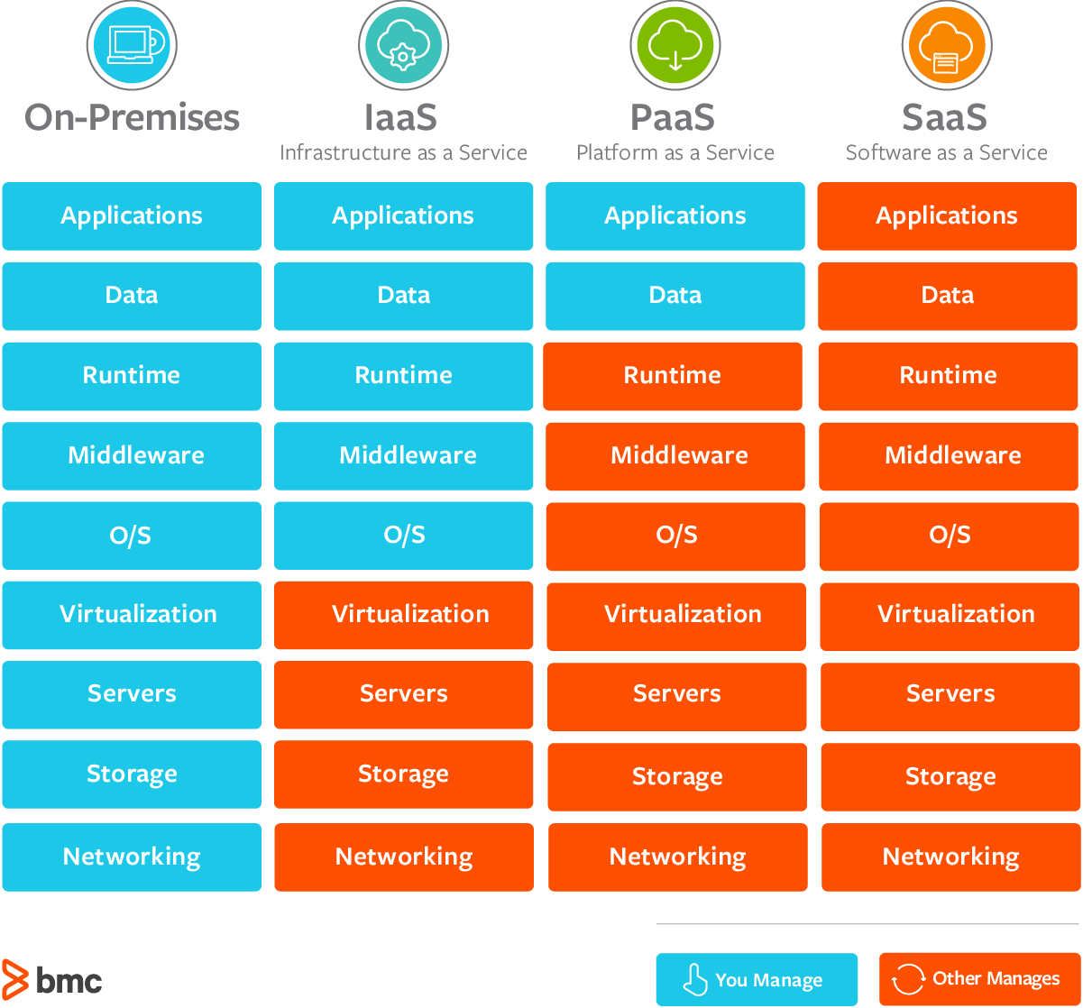

# Common examples of SaaS, PaaS, & IaaS

|  |  |
| --- | --- |
| **Platform Type** | **Common Examples** |
| **SaaS** | Google Workspace, Dropbox, Salesforce, Cisco WebEx, Concur, GoToMeeting |
| **PaaS** | AWS Elastic Beanstalk, Windows Azure, Heroku, Force.com, Google App Engine, Apache Stratos, OpenShift |
| **IaaS** | DigitalOcean, Linode, Rackspace, Amazon Web Services (AWS), Cisco Metapod, Microsoft Azure, Google Compute Engine (GCE) |

## Difference between CapEx vs OpEx

**Capital Expenditure (CapEx):** It is the initial spending of money (whole together) on physical infrastructure, and then deducting that up-front expense over time. The up-front cost from CapEx has a value that reduces over time. All expenses incurred for long-term benefits in the future lie under CapEx.

**Operational Expenditure (OpEx):** It is like a pay-as-you-go service. You can deduct this expense in the same year you spend it. There is no up-front cost, as you pay for a service or product as you use it. It is as the name suggests, the expense of daily operation.

| Context | CapEx | OpEx |
| --- | --- | --- |
| The upfront cost | Significant | None |
| Ongoing cost | Low | Based on usage |
| Tax Deduction | Over-time | Same year |
| Early Termination | No | Anytime |
| Maintenance | Significant | Low |
| Value over time | Lowers | No change |